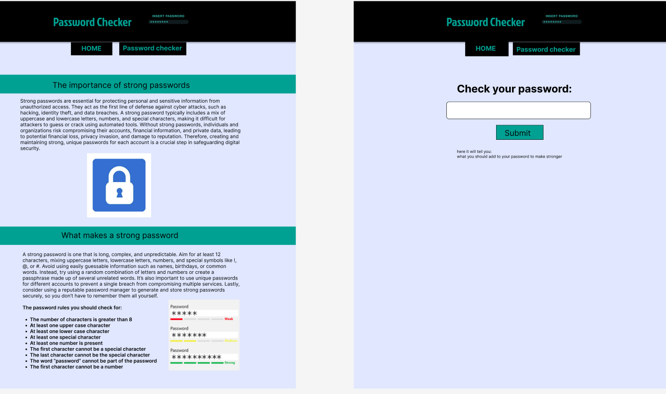
Here is my design for my website

first of all the intended audience of this website would be people wanting to check passwords and make sure they are strong, this means people who know the importance and are creating accounts, mostly people between 18 and 40, who are in job and cyber security is important to them or in there personal . to reflect this to start off my colour scheme is simple and professional, you want to make sure they are taking it seriously and there is no need for bright colours so the subtle blue background, and teal accents are not bold and are colours you may relate to computers. I also went with black writing and heading, this is a darker colour just making it feel professional and making sure the text stands out so it can be read easy.
The heading includes a simple bold lettering this makes it stand out and clear what its supposed to be without any unprofessional font, it also has an image of a password bar, just making it clear what the website is doing and making it stand out and look a bit better, it also will make user the person is not overwhelmed with text and has some visuals making it easier to carry on and digest. I have added appropriate images so its visually appleling as this will attract people and making the text seem less overwhelming and gives a visual aid. It also could be done so if a reader is used.

I have done a simple top bar just that tabs you can clearly see and click on to navigate between pages. Bellow in the body i have separated the sections with colour as personally I think its the clear what each section is and makes it easy to navigate, in the text bellow is just plain simple text in black to make sure it stands out and the subtle blue background making less contrast so people with disablitys may be able to read better. I have also added appropriate images so its visually appleling as this will attract people and making the text seem less overwhelming and gives a visual aid. It also could be done so if a reader is used.
On the page where you can ether you password to check I have done a very simple deign making it easy to use and code without and fuss so it can just be simple and functional, this allows users to see what the box is for with the heading, enter a password into the box, submit the password and bellow where I have said here its will recommend improvements it will print out what the password could include or is missing so it can be even stronger, it could also print a colour here to show if the password is good or bad and even how long it will take to break. The bold title just making it clear what the box is and making it easy to read. This will be good for people with bad vision of divisibility,

